An

Industrial Training Report on

**STRUCTURED QUERY LANGUAGE**

### At

**CELEBAL TECHNOLOGIES**

*Submitted in partial fulfillment of the requirements for the award of the degree of*

**Bachelor of Technology**

in

Computer Science & Engineering (AI)

**Department of Advance Computing**

 (Session 2023-2024)

#### Submitted to - Submitted by-

MS.REENA SHARMA TANISHQ MAHARSHI

(Faculty Coordinators- Industrial Training Seminar) PCE21CA054

# DEPARTMENT OF ADVANCE COMPUTING

## POORNIMA COLLEGE OF ENGINEERING, JAIPUR RAJASTHAN TECHNICAL UNIVERSITY, KOTA

# DECLARATION

I hereby declare that the work which is being presented in the **Industrial Training** report titled

STRUCTURED QUERY LANGUAGE in partial fulfillment for the award of the Degree of **Bachelor of Technology** in **Computer Science & Engineering (AI)** and submitted to the Department of **Advance Computing**, **Poornima College of Engineering, Jaipur**, is an authentic record of my own work carried out at **CELEBAL TECHNOLOGIES** during the session 2023-24 ( V Semester).

I have not submitted the matter presented in this report anywhere for the award of any other Degree.

Signature of the Student with Name & Reg. No.: Place:

Date:

Enclosed: Training Certificate from Company

**CERTIFICATE OF TRAINING**

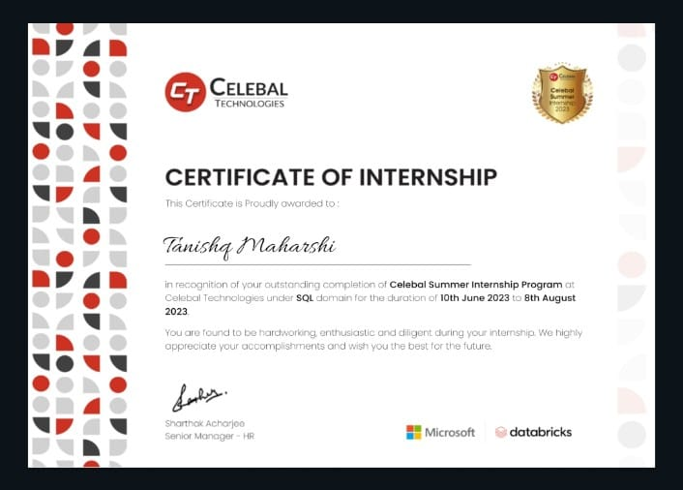



#### DEPARTMENT OF ADVANCE COMPUTING

Date:

**CERTIFICATE**

This is to certify that **Industrial Training** report titled STRUCTURED QUERY LANGUAGE has been submitted by TANISHQ MAHARSHIwith r**egistration number** PCE21CA054 in partial fulfillment for the award of the Degree of **Bachelor of Technology** in **Computer Science & Engineering (AI)** during the session 2023-24, Even Semester. The industrial training work is found satisfactory and approved for submission.

#### Name& Signatures

(Faculty Coordinators-

Industrial Training Seminar)

Date :

Place: Jaipur

HOD, ADVANCE COMPUTING

**TABLE OF CONTENTS**

| **CHAPTER NO.** | **PARTICULARS** | **PAGE NO.** |
| --- | --- | --- |
|  | Title Page | i |
|  | Candidate’s Declaration | ii |
|  | Certificate (s) of all Trainings undergone | iii-v |
|  | Certificate by the Department | vi |
|  | Acknowledgment | vii |
|  | Table of Contents | viii |
|  | List of Tables | ix |
|  | List of Figures | x |
|  | Abstract | 1 |
| 1 | Introduction  1.1 Introduction  1.9 Full name of the Technical Training/Course  1.2 … | 2 |
| 3 |
| 4 |
| 5 |
| 2 | Technical Training Platform  2.1 Introduction  2.2 … | 6 |
| 7 |
| 8 |
| 3 | Training Introduction | … |

**ABSTRACT**

This industrial training program aims to provide participants with a hands-on and in-depth understanding of Structured Query Language (SQL) for effective database management in real-world industrial settings. The training is designed to bridge the gap between theoretical knowledge and practical application, ensuring that participants gain the skills necessary to navigate and manipulate databases efficiently.

The training will cover key aspects of SQL, including database design, data manipulation, and data retrieval. Participants will be exposed to industry-relevant scenarios, case studies, and projects, allowing them to apply theoretical concepts to solve practical challenges commonly encountered in industrial environments.

Key Objectives:

1. **Fundamental SQL Concepts:** Participants will acquire a solid foundation in SQL fundamentals, including database creation, table design, and relationships between tables.
2. **Data Manipulation:** The training will delve into the intricacies of data manipulation, covering essential commands for inserting, updating, and deleting data in a database.
3. **Data Retrieval and Reporting:** Participants will learn advanced querying techniques to extract meaningful insights from databases, including the use of joins, subqueries, and aggregate functions.
4. **Optimizing Database Performance:** The program will address strategies for optimizing database performance, indexing, and normalization to ensure efficient data storage and retrieval.
5. **Security and Access Control:** The training will emphasize the importance of securing databases through user authentication, authorization, and best practices for protecting sensitive information.
6. **Real-world Projects:** Hands-on projects will be integrated into the training, allowing participants to apply their knowledge in practical scenarios commonly encountered in industrial settings.
7. **Integration with Application Development:** Participants will explore the integration of SQL with programming languages and frameworks, enabling them to work seamlessly with database-backed applications.

By the end of the training, participants will have a comprehensive understanding of SQL and its application in industrial contexts, empowering them to contribute effectively to database management tasks within their respective organizations. The program's emphasis on practical skills and real-world scenarios ensures that participants are well-prepared to tackle the challenges of database management in today's dynamic industrial landscape.

Top of Form

INTRODUCTION

One of the most effective tools for maintaining and working with relational databases is SQL, or Structured Query Language. This technical training gives participants a thorough understanding of SQL and the skills they need to effectively interface with databases. This program is tailored to accommodate a range of skill levels, from novices seeking to build a solid foundation to seasoned professionals seeking to expand their SQL knowledge.

I have done my SQL training with Celebal Technologies.

* To get the internship in Celebal Technologies, you have to give an Online Technical Assessment.
* The pattern of question for technical assessment will be computer science MCQs.
* In my training of SQL, I worked on **MY SQL Server** and **Oracle**.
* MySQL is a fully managed database service for transactions, real- time analytics across data warehouses and data lakes, and machine learning services, without the complexity, latency, and cost of ETL duplication. It is available on OCI, AWS, and Azure.
* Oracle is a relational database management system(RDBMS) that’s used by global enterprises to manage and process data across wide and local area networks.
* The working days of the company is from Monday to Friday.
* The working time is from 10:00 A.M. to 07:00 P.M. for the employees.
* The internship timing is from 3:30 P.M to 5:00 P.M.

In conclusion, the "Mastering SQL" technical training offers a structured and comprehensive approach to learning SQL, empowering individuals to harness the full potential of relational databases. Whether you aim to boost your career prospects or enhance your current skill set, this training provides a solid foundation for anyone looking to navigate the intricacies of SQL with confidence and proficiency. Get ready to embark on a journey of mastering SQL and unlocking new possibilities in the realm of database management.

#### Technical Training Platform

The training adopted a hands-on approach, allowing participants to apply theoretical concepts in a practical environment. Regular assessments and quizzes were conducted to gauge understanding, and interactive sessions facilitated open discussions on challenges and problem-solving strategies.

I completed my training SQL from Celebal Technologies in which I used platforms like MySql , Oracle etc.

The training adopted a hands-on approach, allowing participants to apply theoretical concepts in a practical environment. Regular assessments and quizzes were conducted to gauge understanding, and interactive sessions facilitated open discussions on challenges and problem-solving strategies.

**Key Learnings:**

1. **Efficient Querying:**
   * Proficient use of SQL commands for data retrieval and manipulation.
2. **Database Design:**
   * Application of normalization principles to design robust databases.
3. **Problem-Solving:**
   * Critical thinking in resolving complex database-related issues.
4. **Real-world Application:**
   * Bridging theory with practical scenarios for enhanced learning.

**Challenges and Solutions:**

Throughout the training, I encountered challenges that demanded creative problem-solving. Collaborative discussions with peers and guidance from the training facilitators enabled me to overcome obstacles and deepen my understanding of SQL.

**Training introduction**

Relational database systems' mainstay, SQL, is essential to data administration and retrieval. We cover syntax, advanced features, and foundational principles as we dig into the nuances of SQL. A thorough grasp of database architecture, normalization methods, and useful SQL applications in actual settings will be imparted to participants. With a hands-on approach, the course enables participants to work with SQL databases, create queries, and resolve frequent problems.

**Technology Description:**

SQL, the backbone of relational database systems, plays a pivotal role in data management and retrieval. Our training delves into the intricacies of SQL, covering fundamental concepts, syntax, and advanced features. Participants will gain a profound understanding of database design, normalization techniques, and practical applications of SQL in real-world scenarios. The training embraces a hands-on approach, allowing participants to interact with SQL databases, write queries, and solve challenges commonly encountered in the field.

* SQL syntax consists of statements that define what operation to perform. It follows a specific structure and includes keywords, expressions, and clauses that form a valid SQL statement.
* DML commands (SELECT, INSERT, UPDATE, DELETE) allow users to manage and manipulate data in a database. SELECT retrieves data, INSERT adds new records, UPDATE modifies existing records, and DELETE removes records from a table.
* **INSERT Statement**
* Inserts new rows into a table.
* Example:

INSERT INTO Customers (CustomerName, ContactName) VALUES ('Company1', 'John Smith’);

* **UPDATE Statement**
* Modifies existing data in a table.
* Example:

UPDATE Customers SET ContactName = 'Jane Doe' WHERE CustomerID = 1;

* **SELECT Statement**
* SELECT statement is used to retrieve data from a database.
* Example:

SELECT * FROM Customers;

* **DELETE Statement**

DELETE statement removes records from a table based on specified conditions.

Example:

DELETE FROM Customers WHERE CustomerID = 1;

* DDL commands (CREATE, ALTER, DROP) enable users to define, modify, and delete database structures. CREATE creates new tables, ALTER modifies existing structures, and DROP deletes tables and databases.
* **CREATE Statement**
* This statement is used to create new database objects, such as tables, views, indexes, and procedures.
* Example:

CREATE TABLE employees (

employee_id INT PRIMARY KEY,

first_name VARCHAR(50),

last_name VARCHAR(50),

salary DECIMAL(10, 2)

);

* **ALTER Statement**
* This statement is used to modify existing database objects, such as adding, modifying, or dropping columns in a table.
* Example:

ALTER TABLE employees

ADD COLUMN email VARCHAR(100);

* **DROP Statement**
* This statement is used to delete existing database objects, such as tables or indexes.
* Example:

DROP TABLE employees;

These are some basic commands of SQL.

**Exposure Level:**

The SQL Training program is designed to provide exposure at multiple levels, ensuring participants experience a holistic learning journey:

1. **Foundational Understanding:**
   * Acquire a solid grasp of fundamental SQL concepts and principles.
2. **Practical Application:**
   * Engage in hands-on exercises and real-world projects to apply theoretical knowledge in practical scenarios.
3. **Advanced Topics:**
   * Explore advanced SQL features, such as stored procedures, triggers, and transaction management, to deepen expertise.
4. **Problem-Solving Skills:**
   * Develop critical thinking and problem-solving skills in the context of database management.

**Conclusion:**

In conclusion, this SQL Training program serves as a gateway to mastering one of the most widely used languages in the world of data management. Whether you are looking to kickstart your career, enhance your current skill set, or stay updated with industry trends, our training provides a comprehensive and practical approach to SQL. Join us on this educational journey, where you'll gain the confidence and proficiency needed to navigate the complexities of database management with ease.

PROJECT

* During my internship period I made a project for practicing.
* This project provides a foundation for an online bookstore database management system.
* The project can be expand by adding more features such as user authentication, reviews, book categories, and online payment integration.

SCREENSHOTS –

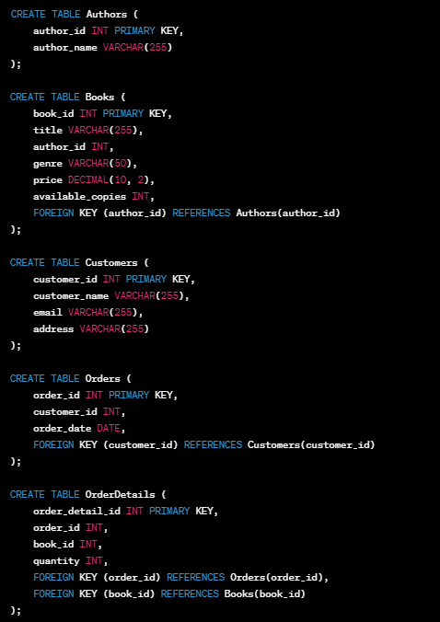

Creating Tables:

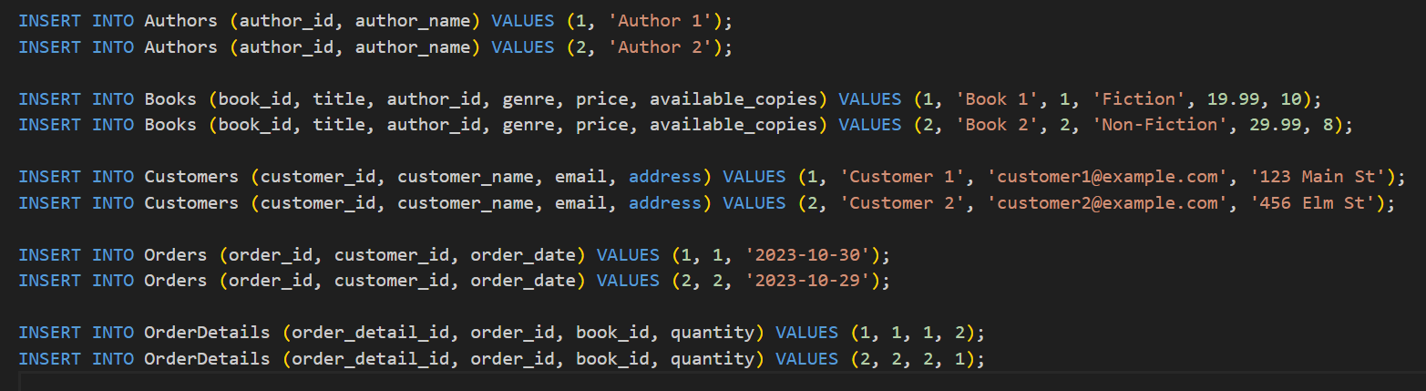

Sample Data Insertions

* Sample Queries:

1. Retrieve all books along with there authors:

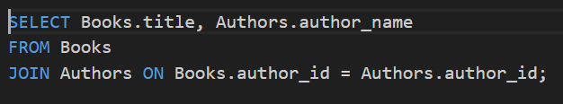

1. Retrieve customer order along with book details:

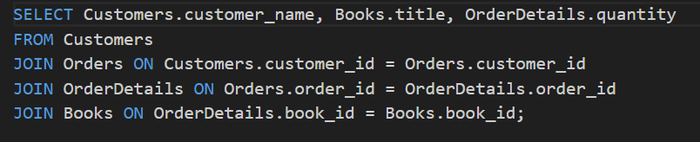

Top of Form

**Real-World Application of SQL:**

* **E-commerce**

SQL can be used to track inventory, process orders, and analyze customer data to improve sales and marketing strategies.

* **Healthcare**

SQL can be used to manage patient data, track medical histories, and analyze treatment outcomes to improve patient care and outcomes.

* **Finance**

SQL can be used to manage financial data, track investments, and analyze market trends to inform investment strategies and decision-making.

**CONCLUSION**

In conclusion, the SQL training program has provided participants with a transformative learning experience, equipping them with the essential skills and knowledge to excel in the dynamic field of database management. Throughout the training, participants have gained a comprehensive understanding of Structured Query Language (SQL), from foundational concepts to advanced features.

The hands-on approach employed in this training has allowed participants to not only grasp theoretical concepts but also apply them in practical scenarios. The real-world projects and exercises have been instrumental in reinforcing the learning, enabling participants to confidently navigate databases, write efficient queries, and address challenges commonly encountered in the industry.

As a result of this training, participants have elevated their exposure levels, starting from foundational principles and progressing to advanced topics such as database design, normalization techniques, and the implementation of complex SQL features like stored procedures and triggers. The program has not only enhanced technical proficiency but has also fostered critical thinking and problem-solving skills essential for success in database management roles.

This conclusion marks not just the end of a training program but the beginning of a journey for participants to leverage their newfound SQL expertise in their professional endeavors. We extend our congratulations to all participants for their dedication and commitment throughout the training. We are confident that the skills acquired will significantly contribute to their success in the ever-evolving landscape of database management.

We encourage participants to continue applying and expanding their knowledge in real-world scenarios, and we look forward to witnessing their continued success in leveraging SQL to drive efficiency and innovation in their respective roles.

Thank you for being a part of this enriching SQL training program. We wish you continued success in your SQL endeavors!